Papers written by
Australian Maths Software

YEAR 11
2016

REVISION 1

MATHEMATICS
SPECIALIST
UNITS 1 & 2

SEMESTER TWO
SOLUTIONS

SECTION 1 – Calculator-free
Question 1 (7 marks)
(a) (i) 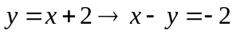
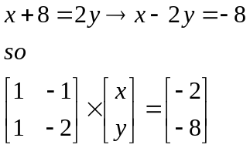
✓

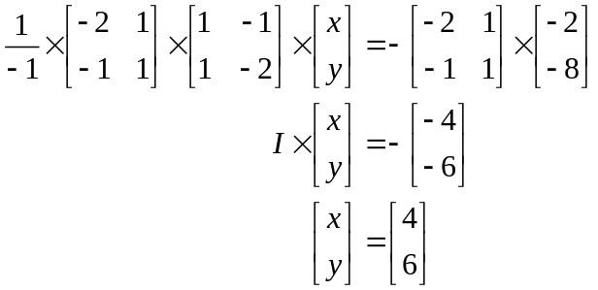
✓

✓

✓

(b) 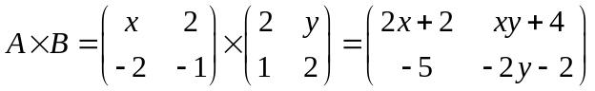
✓

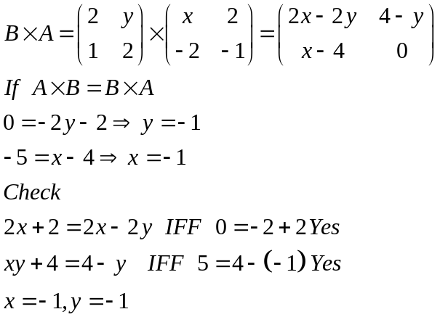
✓

✓

Question 2 (6 marks)
(a) (i) 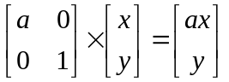
Dilates the point (x, y) in the direction of the x axis by a factor of a. ✓

(ii) 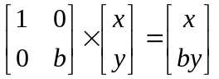
Dilates the point (x, y) in the direction of the y axis by a factor of b. ✓
(b) 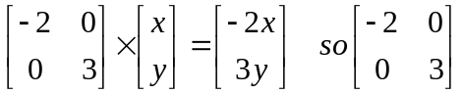 ✓✓
Question 3 (4 marks)
(a) 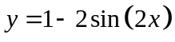 on the domain 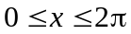.

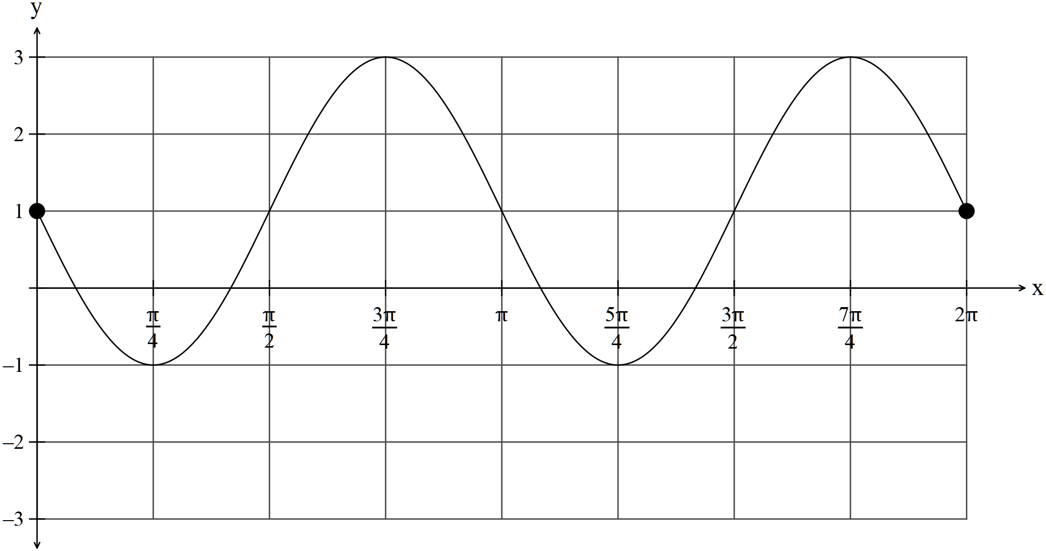
✓✓

(b) 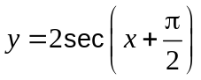on the domain 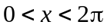
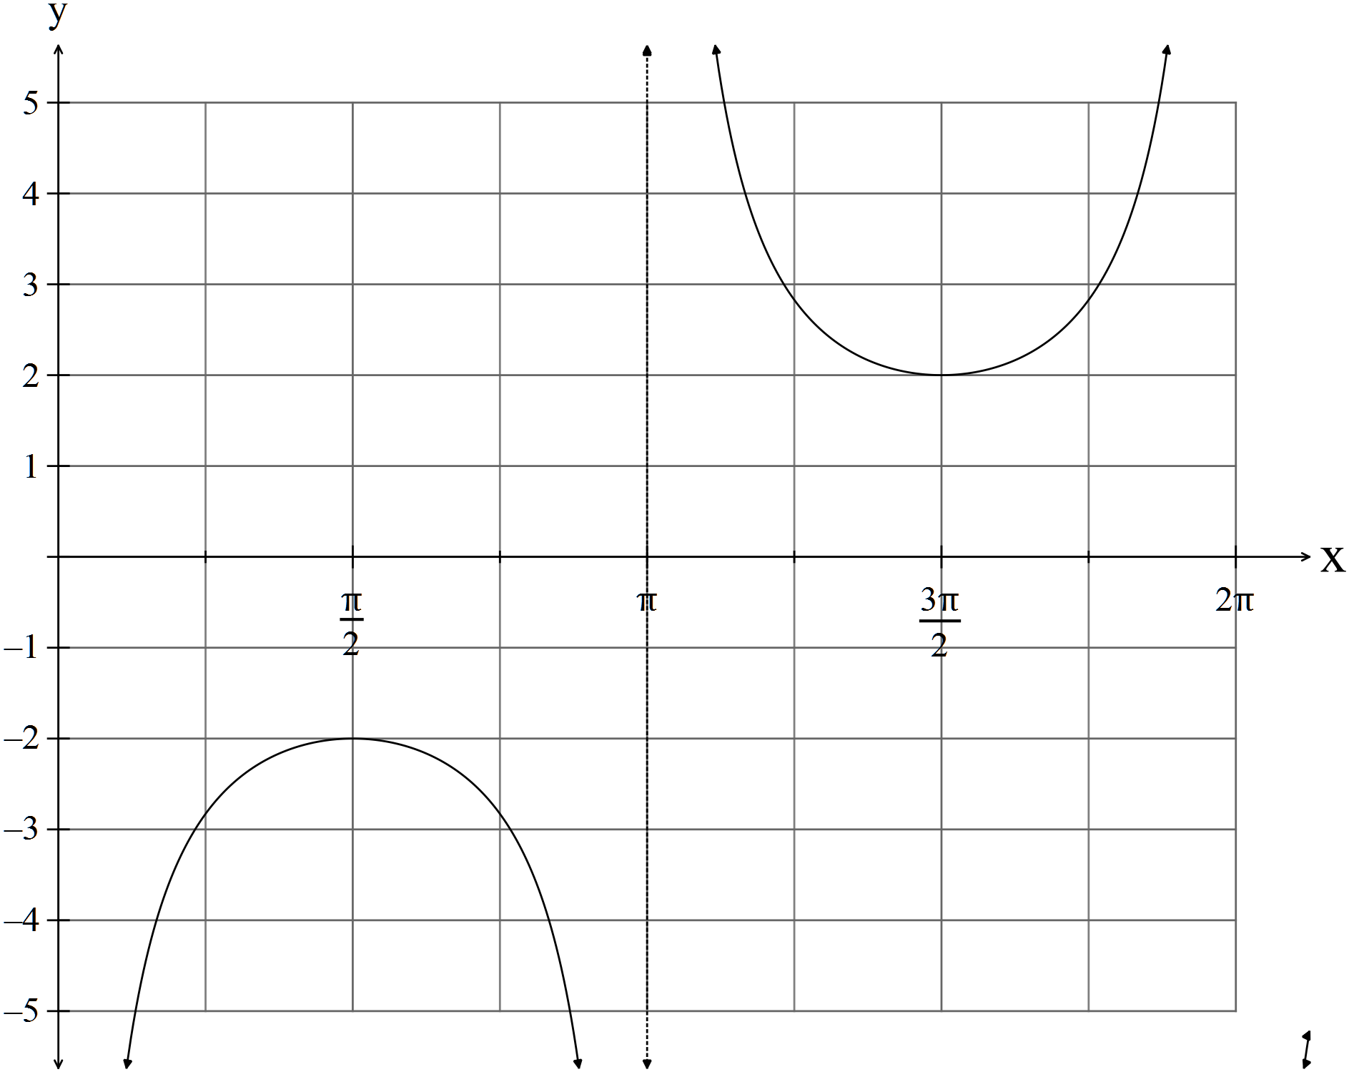
✓

✓

Question 4 (8 marks)
(a)
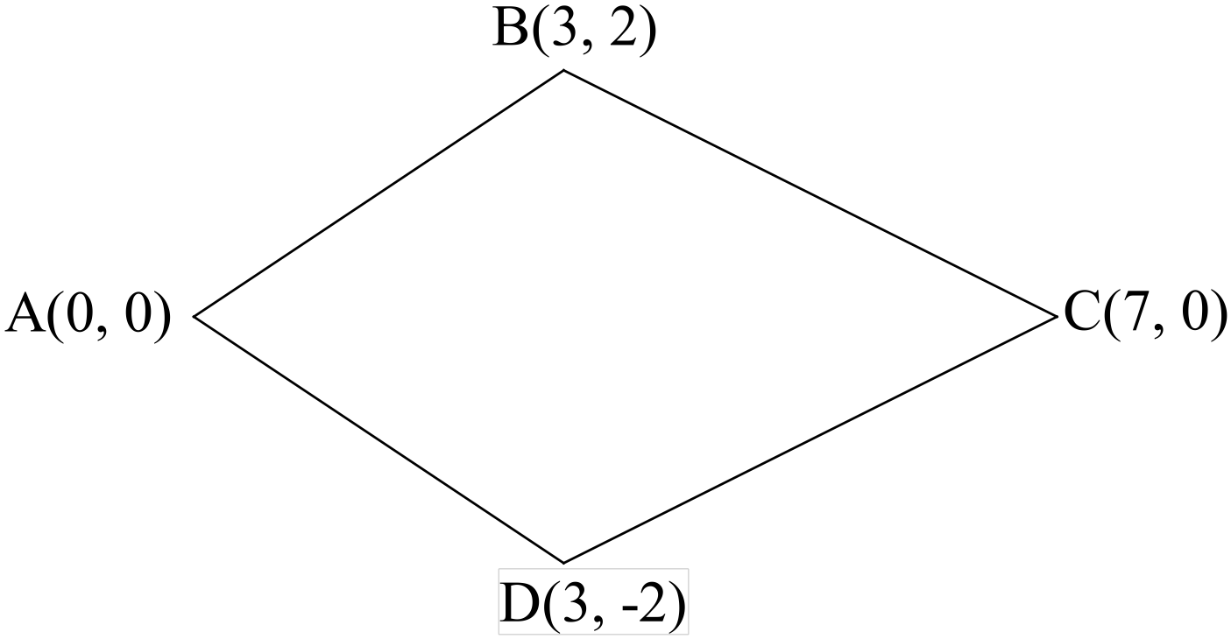
(i) 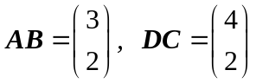
✓


Therefore  is not a parallelogram.

(ii) 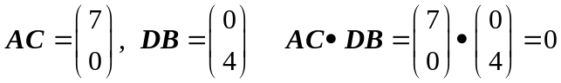
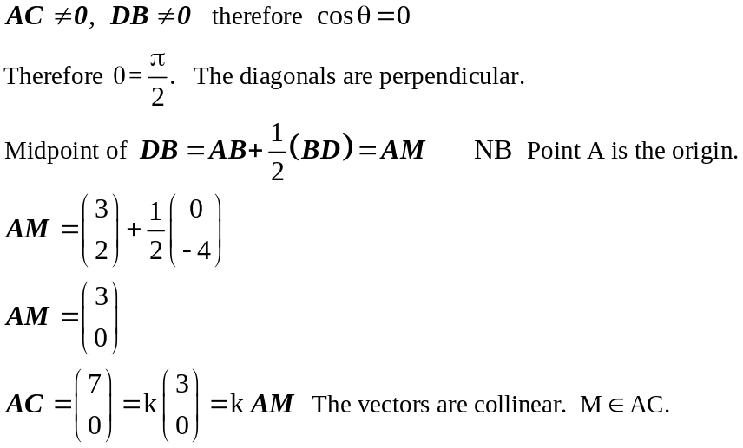
✓

✓

✓

Therefore the midpoint of one diagonal belongs to the other diagonal and they are
✓

perpendicular.
Therefore is a kite,

(b) A(1,1) and 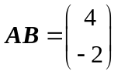
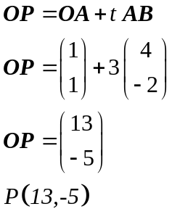
✓

(c) 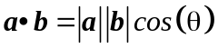
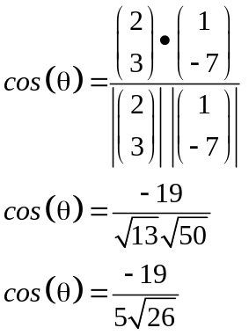
✓

✓

Question 5 (11 marks)
(a) (i) 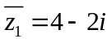
(ii) 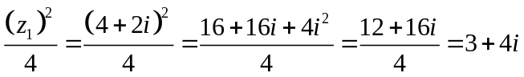
✓

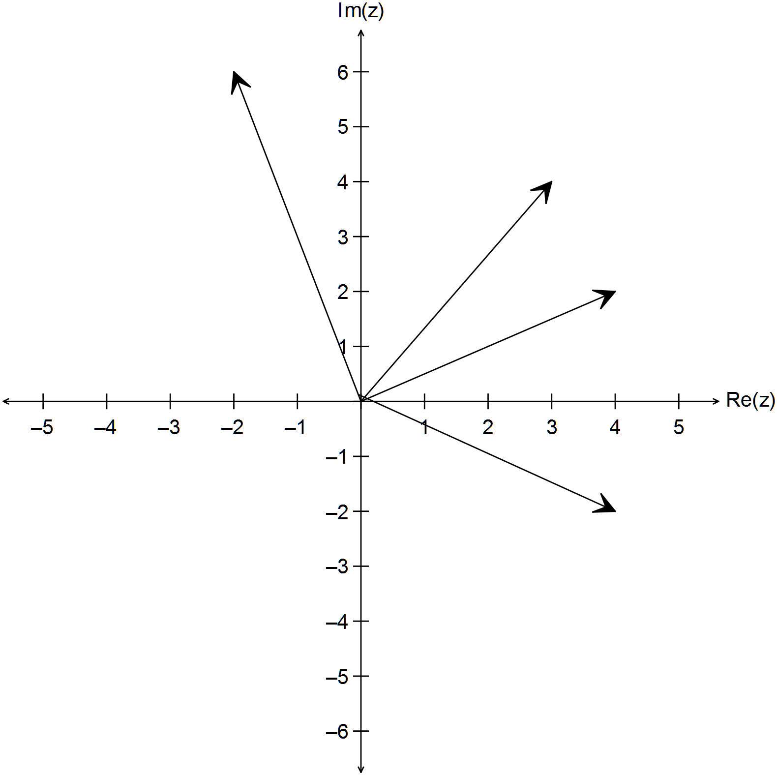
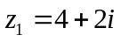
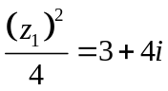
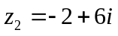
✓

✓

(b) (i) 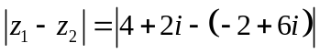
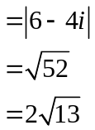
✓

✓

✓

(ii) 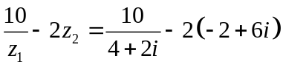
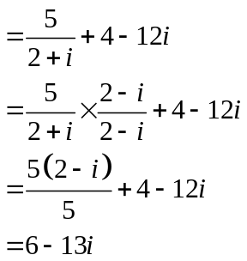
✓

✓

✓

(iii) 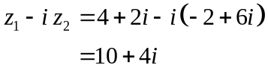
✓

Question 6 (9 marks)
(a) The converse is
✓

“If the opposite angles are supplementary, then the quadrilateral is cyclic.”

(b) Prove that “The tangents drawn to a circle from an external point are equal.”
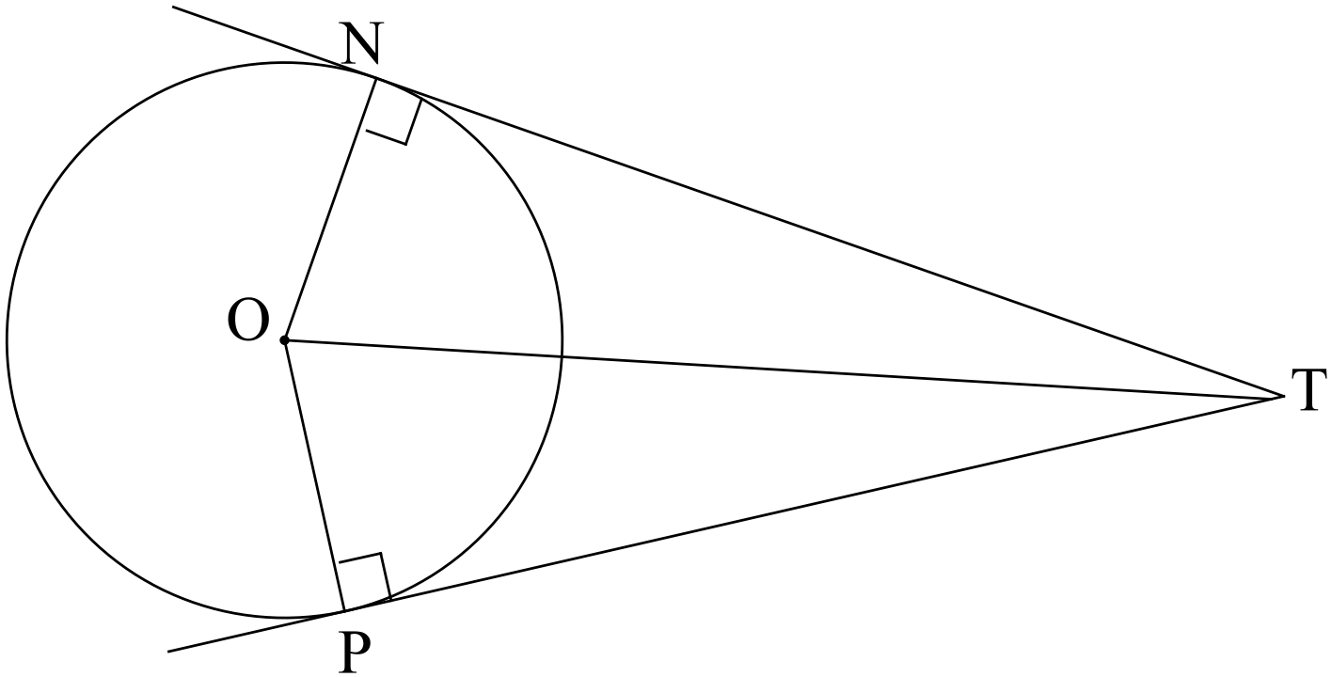
Let O be the centre of the circle, N and P the points of contact of the tangents
✓

and T the point of intersection of the tangents.

Join ON, OP and OT.

In ONT and OPT
(i) ONT = OPT = 90^{O} Tangents are perpendicular to radius at the point of contact.
(ii) ON = OP Equal radii
✓

(iii) OT = OT Same line
 Right angle, hypotenuse, side
✓

✓

Therefore NT = PT
Therefore “The tangents drawn to a circle from an external point are equal.”

(c) Prove the following using vectors:
“If the midpoints of the adjacent sides of a quadrilateral are joined,
then the resulting quadrilateral is a parallelogram.”

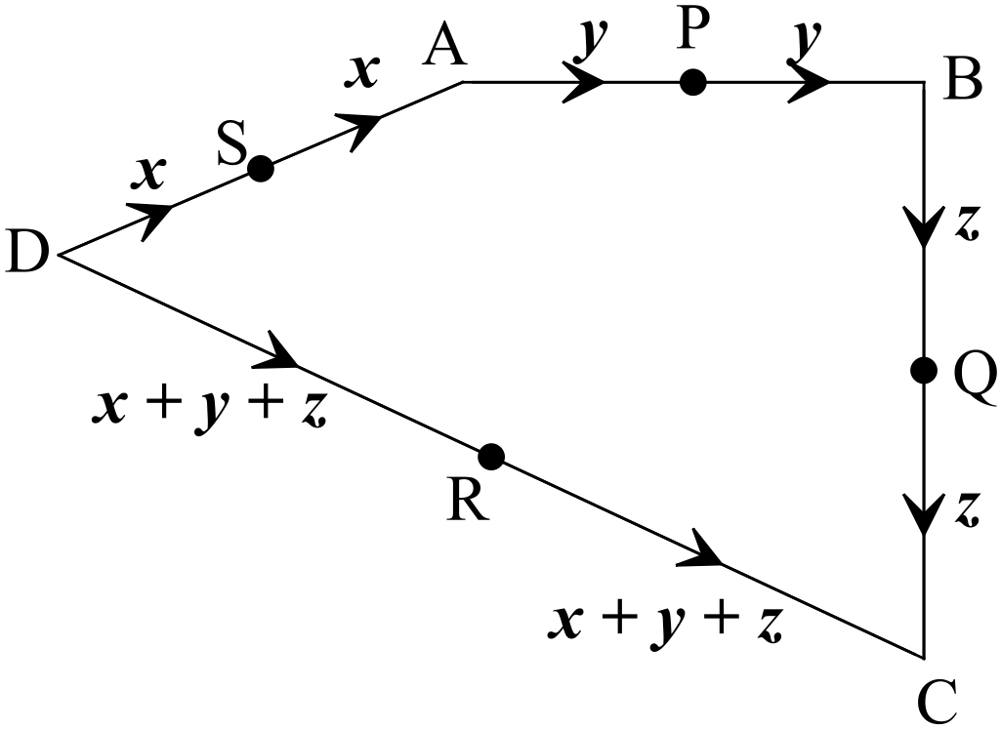
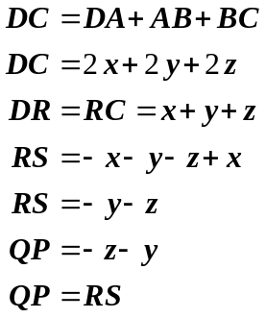
✓

✓

✓

✓

Equal and parallel sides.
Therefore RSPQ is a parallelogram
Question 7 (7 marks)
(a) 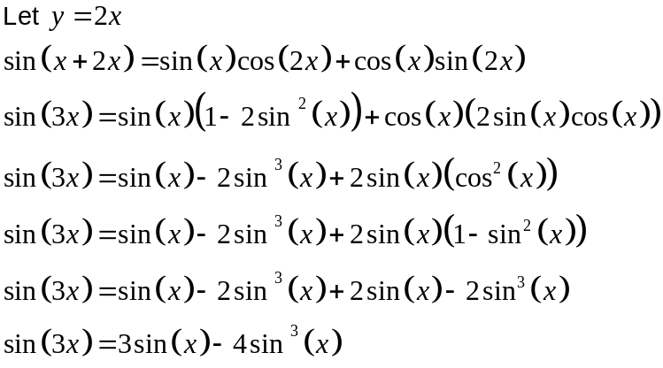
✓

✓

✓

(b) Solve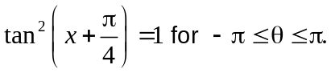
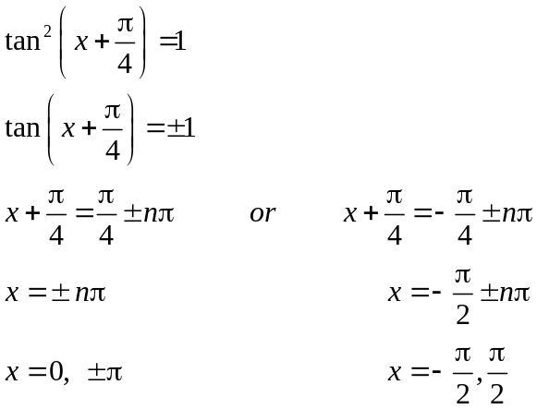
✓

✓

✓

✓

END OF SECTION ONE
SECTION 2 – Calculator-assumed
Question 8 (5 marks)
(a) 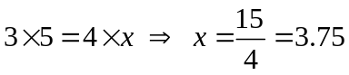
✓

When two chords intersect each other inside a circle, the products of their segments are
✓

equal.

(b)
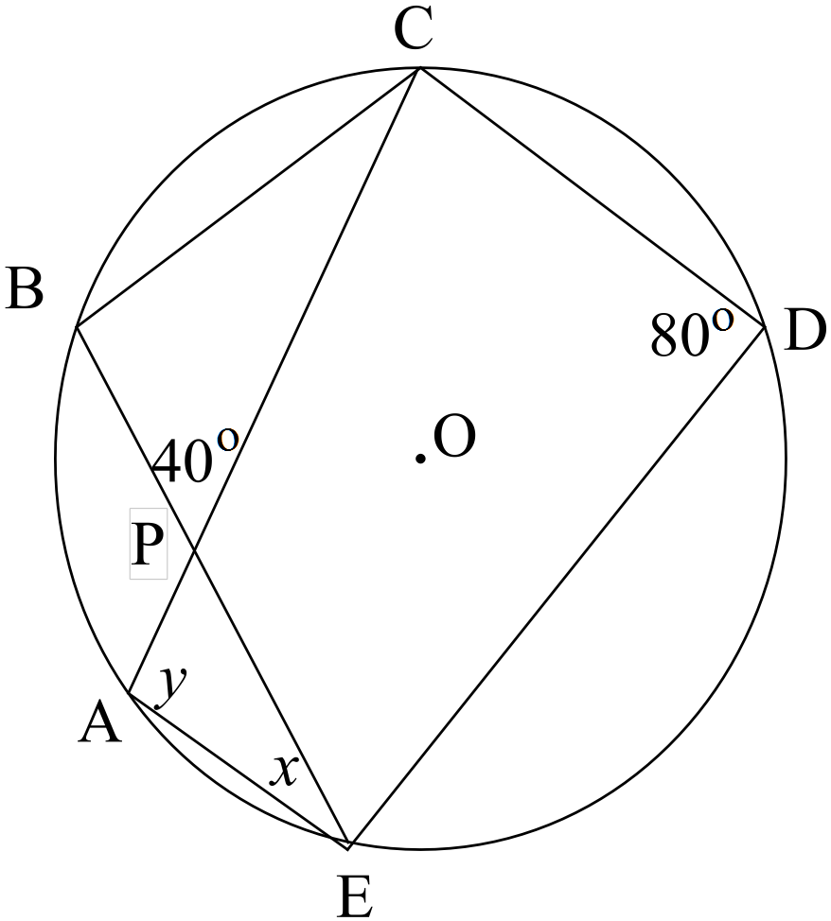
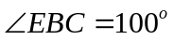 The opposite angles in a cyclic quadrilateral are supplementary.
✓

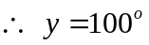 Two angles at the circumference subtended by the same arc are
equal.
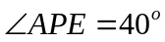 Vertically opposite angles.
✓ reasons

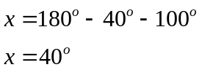Angles in a triangle add to 180º.
✓

Question 9 (11 marks)
(a) (i) 0.9 (units to the turning point) ✓✓
(ii) As p increases, the graph moves to the left and vv. ✓✓
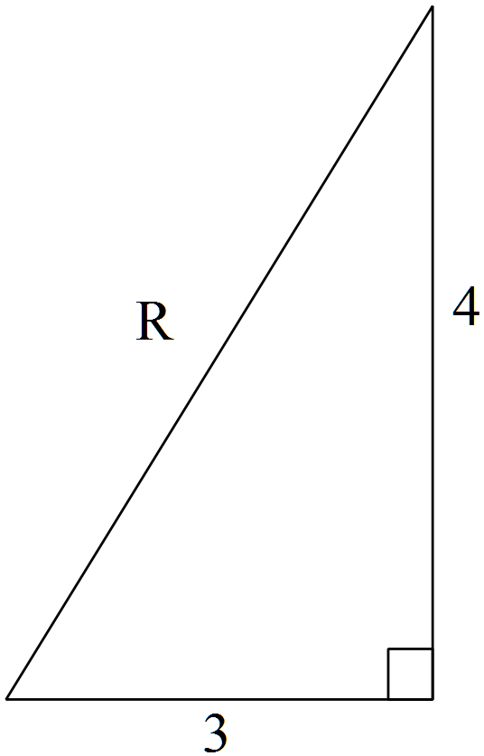 (iii) 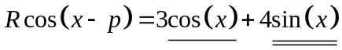
✓
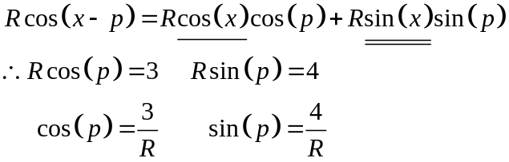
✓
Pythagoras 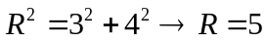
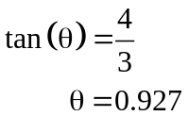
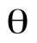

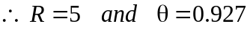
✓
✓
(iv) 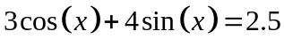
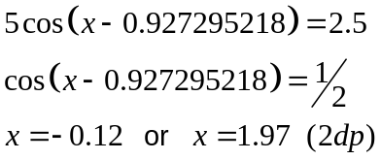
✓
✓
✓

(b) 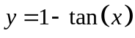 ✓✓
Question 10 (7 marks)
✓
✓
(a) 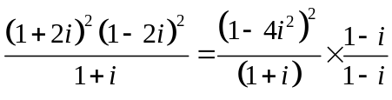
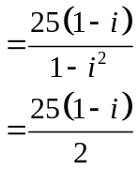
✓
(b) 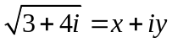
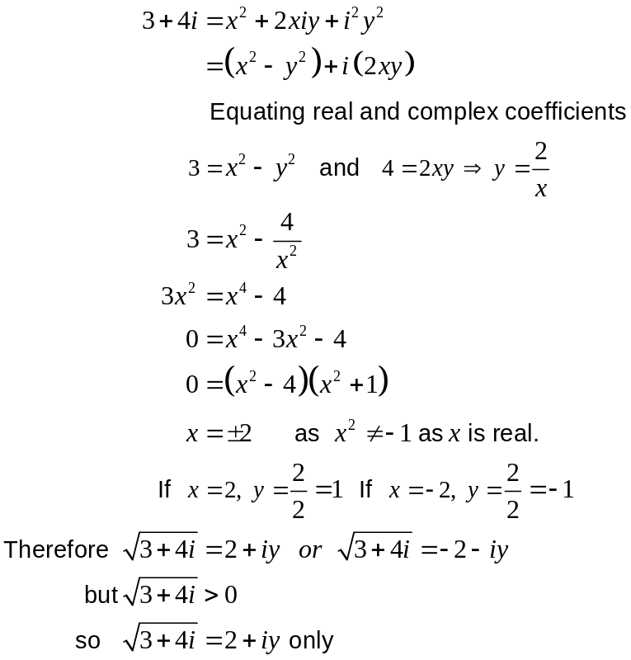
✓
✓
✓
✓
Question 11 (12 marks)
(a) (i) 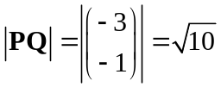 ✓
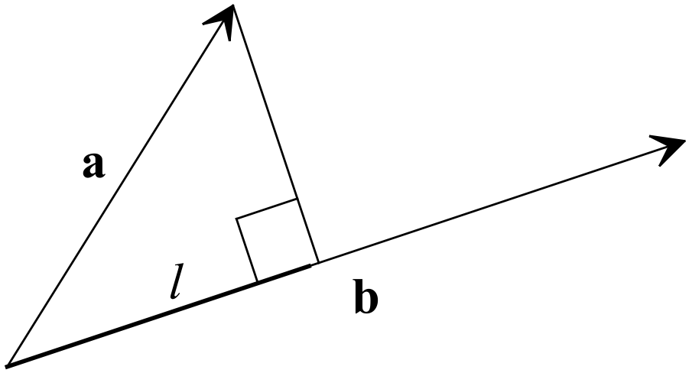 (ii) 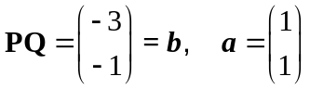
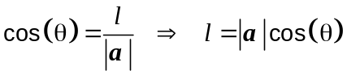
✓
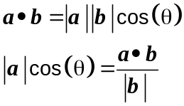
✓
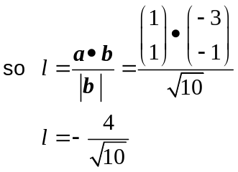
✓
(b) 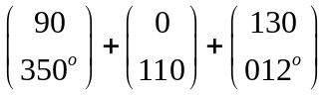
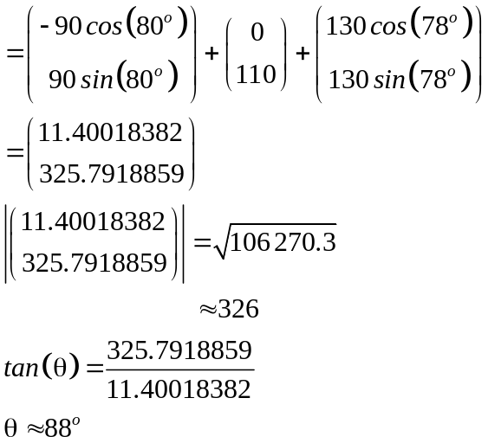
✓
✓
✓
The magnitude is 326 N and the direction is 088º.
✓
They will not have to use the tractor.
.
(c) Use a vector proof to show that
“The sum of the squares of the lengths of the diagonals of a parallelogram is equal
to the sum of the squares of the lengths of the sides.”
Use the diagram below:
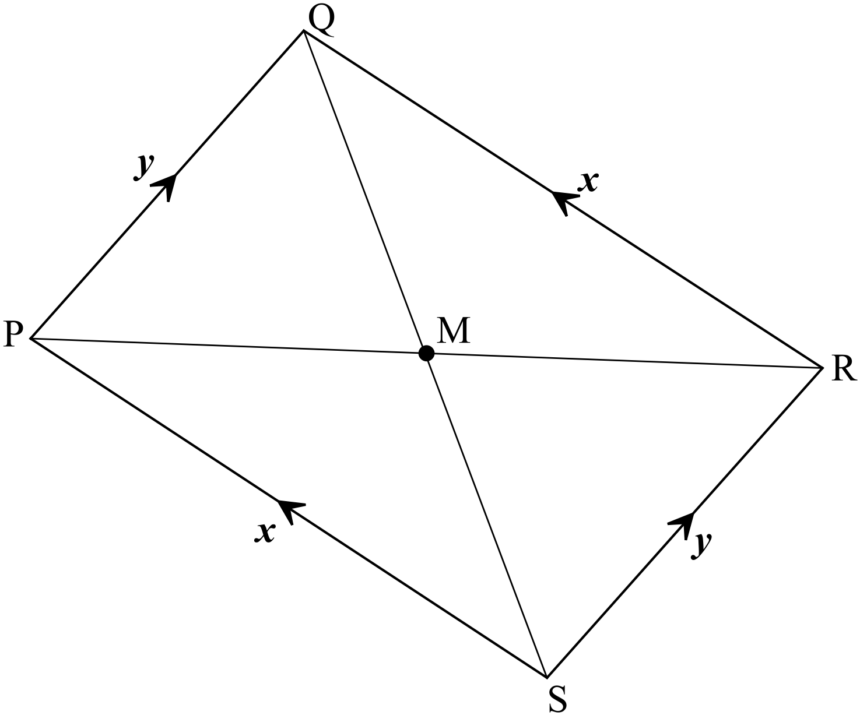
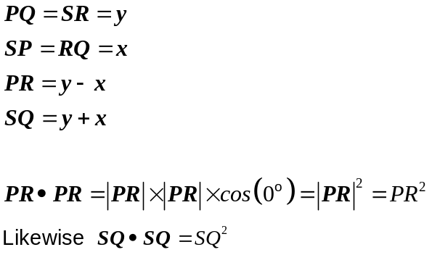
✓

✓

✓

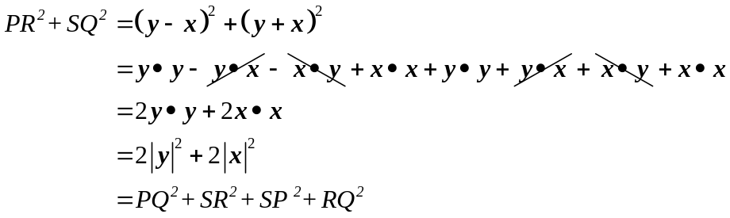
✓

✓

 “The sum of the squares of the lengths of the diagonals of a parallelogram is equal
to the sum of the squares of the lengths of the sides.”

Question 12 (9 marks)
(a) 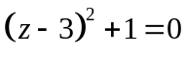
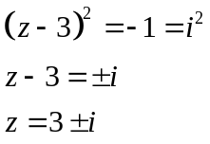
✓

✓

(b) (i) 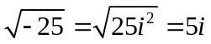 ✓

(ii) 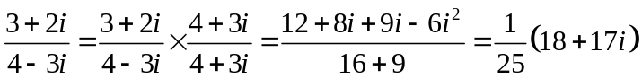
✓

✓

✓

(c) 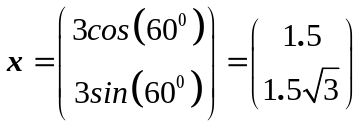
✓

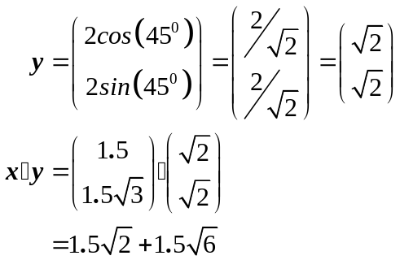
✓

✓

Question 13 (6 marks)
(a) “If Donna does not go to the library, then it is not Tuesday.” ✓

(b) Therefore Big Boy has four legs. ✓

(c) Use a proof by contradiction to prove that there are infinitely many prime numbers.
Suppose there are not infinitely many prime numbers.
i.e. there is a finite number of prime numbers 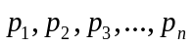
✓

Consider the number 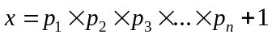.
leaves a remainder of 1 when it is divided by any of the prime numbers since each of them divides evenly into 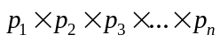
✓

i.e. is not divisible by any prime number and leaves a remainder of 1.
✓

This means is also a prime number.
Contradiction.
✓

Therefore our assumption that there are not infinitely many prime numbers is incorrect.
Therefore, there are infinitely many prime numbers.
Question 14 (9 marks)
(a) Each initial can take be one of the 26 English letters, meaning there are
✓

26 x 26 = 676 possible values for the first and last.
If the first 676 Concert Hall patrons have different combinations of the first and second letter, the 677th person must match someone.
✓

Therefore if 872 people turn up, there will be at least two people in the hall who have the same first and last initial in their names.
(b) 3! = 6 ✓
(c)
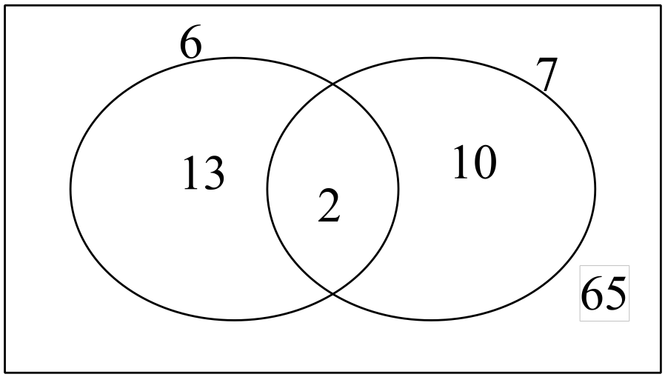
There are 15 multiples of 6 in 90.
✓

There are 12 multiples of 7 in 90.
✓

There are 2 multiples of 42 in 90.
✓

So 90 – 25 = 65

(d) Prove that 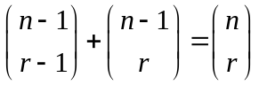
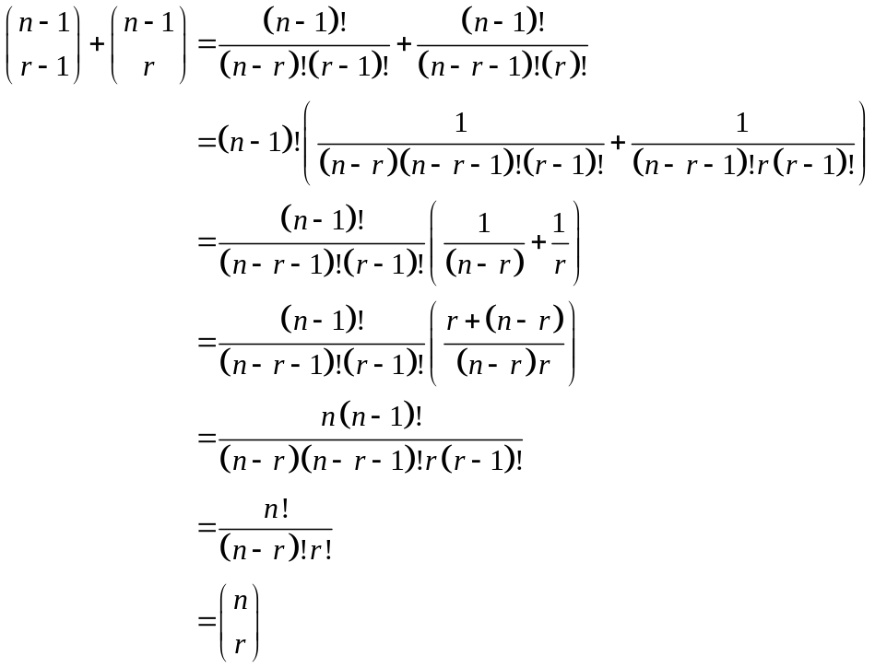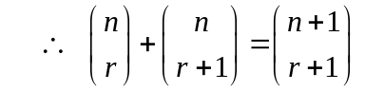
✓
✓
✓
Question 15 (6 marks)
(a) 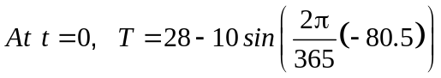
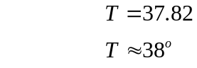
✓

(b) Using calculator, minimum at t =171.75, about 172 days.
January 31
February 28
March 31 90
April 30 121
✓

May 31 151 to here
June 22 173
✓

The minimum expected temperature occurs about June 22

(c) Intersection at t = 104.4 and t = 239.1
June 30 203
July 31 234
✓

90+14 = 104 April 14-15
✓

234 +5 =239 August 5
The temperature is expected to be less than 24º between approximately April 15 and
August 5.
✓

(c) At T = 32, t = 56.594 and t =286.906
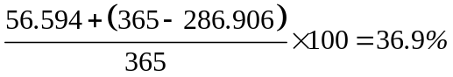
✓

About 37% of days have temperatures greater than 32º.
Question 16 (4 marks)
Prove 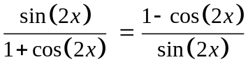
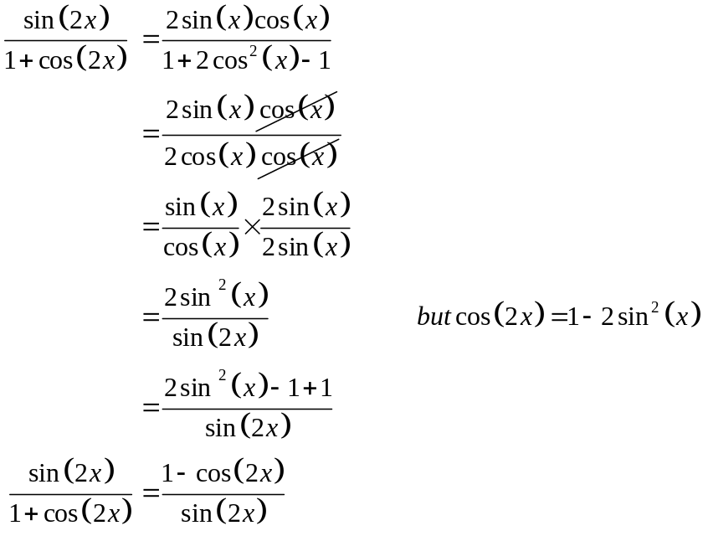
✓

✓

✓

✓

Question 17 (14 marks)
✓

✓

(a) (i) 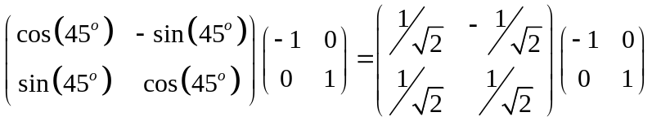
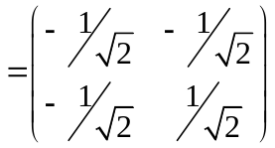
✓

(ii) 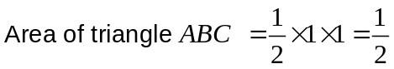
✓

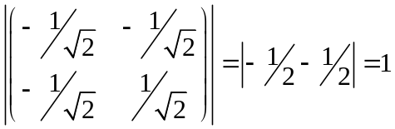
✓

Therefore the areas are the same
✓

The area of triangle A”B”C”D is 0.5 units².
(iii) 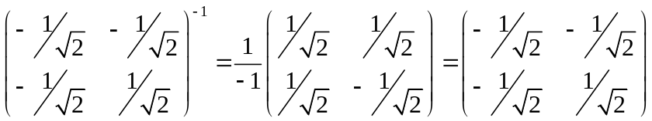
✓✓ -1/error

(b) (i) 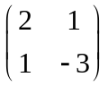
✓✓ -1/error

(ii) 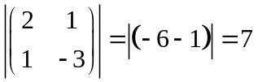
✓

✓

(c) (i) 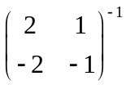 does not exist because the determinant is equal to 0.
✓

This means the matrix to transform quadrilateral A’B’C’D’ back to quadrilateral
✓

ABCD cannot be found.

(ii) 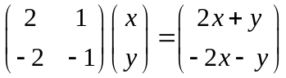
✓

✓

For example (0,0), (1,0), (1,1), (0,1) (0,0), (2, -2), (3, -3),(1,-1)
which is graphed below:
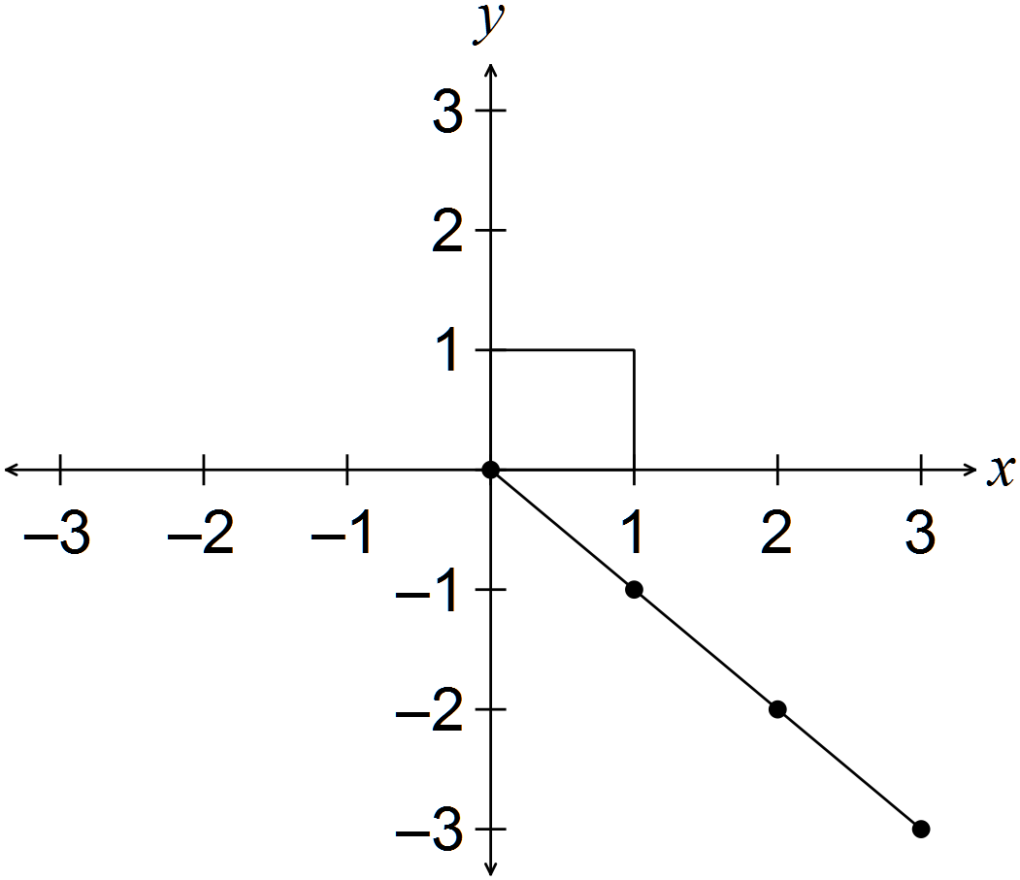
Question 18 (8 marks)
(a) (i)
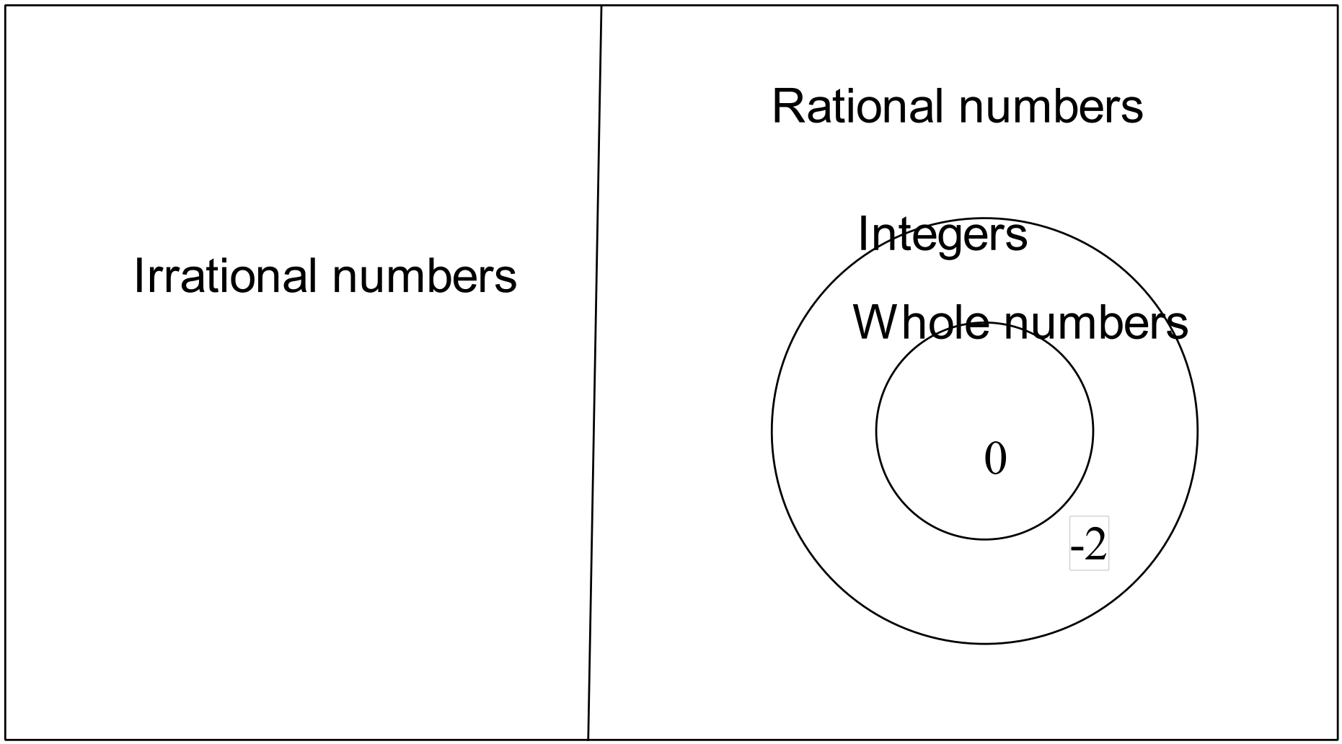

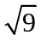
✓✓ -1/error

(ii) A transcendental number does not fit into the set of numbers above.
For example 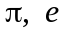

(b) Prove using mathematical induction that 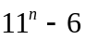 is divisible by 5.
Test for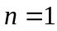.
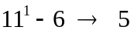
✓

So divisible by 5 for .
✓

Assume valid for i.e. that 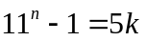

Test for 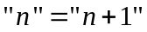
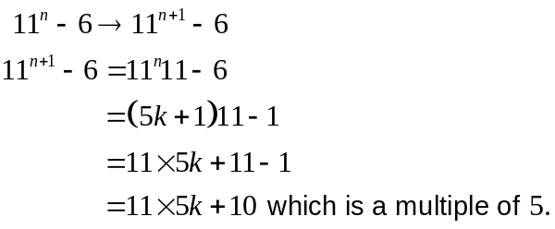
✓

✓

So, if valid for n, then valid for n+1.
Valid for n = 1, so valid for n = 2 etc.
✓

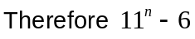 is divisible by 5.
Question 19 (7 marks)
✓

✓

(a) 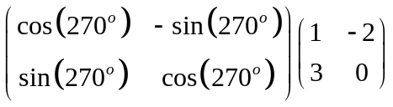
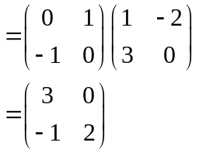
✓

✓

✓

(b) (i) 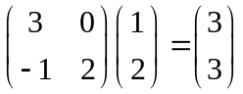 Therefore P’’(3, 3)
(ii) 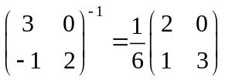
✓

End of solutions

